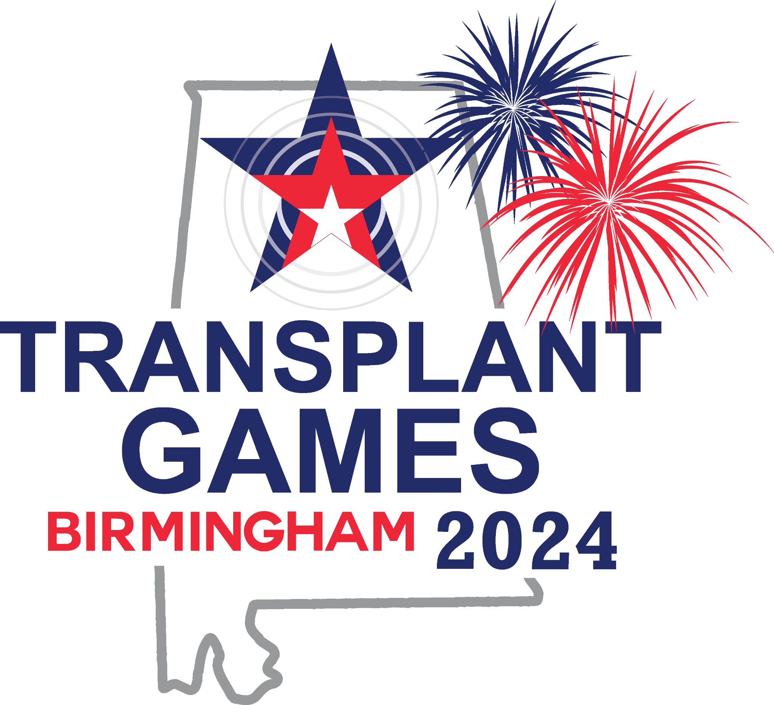

Donor Quilts

Donor Quilts are a beautiful way for donor families, friends, and transplant recipients to pay tribute to their loved ones. The quilts are meant to honor these heroes who offered others a second chance at life. Transplant Life Foundation displays its quilts at various public events and at the biennial Transplant Games of America. We encourage each team to bring a donor quilt to be on display throughout the entire duration of the Games.

Displaying your quilt at the Transplant Games
If you would like your donor quilt to be displayed at the 2024 Transplant Games in Birmingham, Al you will need to complete the Quilt Display Submission Form and bring your quilt to the Games with you.
We suggest you transport your quilt in a sealed bag that is clearly marked with your name, email address and phone number. At the Games, you can drop your quilt off on July 5-6, 2024, at a designated table near the registration area. TGA staff will arrange for your quilt to be displayed, and then taken down at the close of the Games. You can then pick up your quilt on July 10th at the same location you dropped it.

