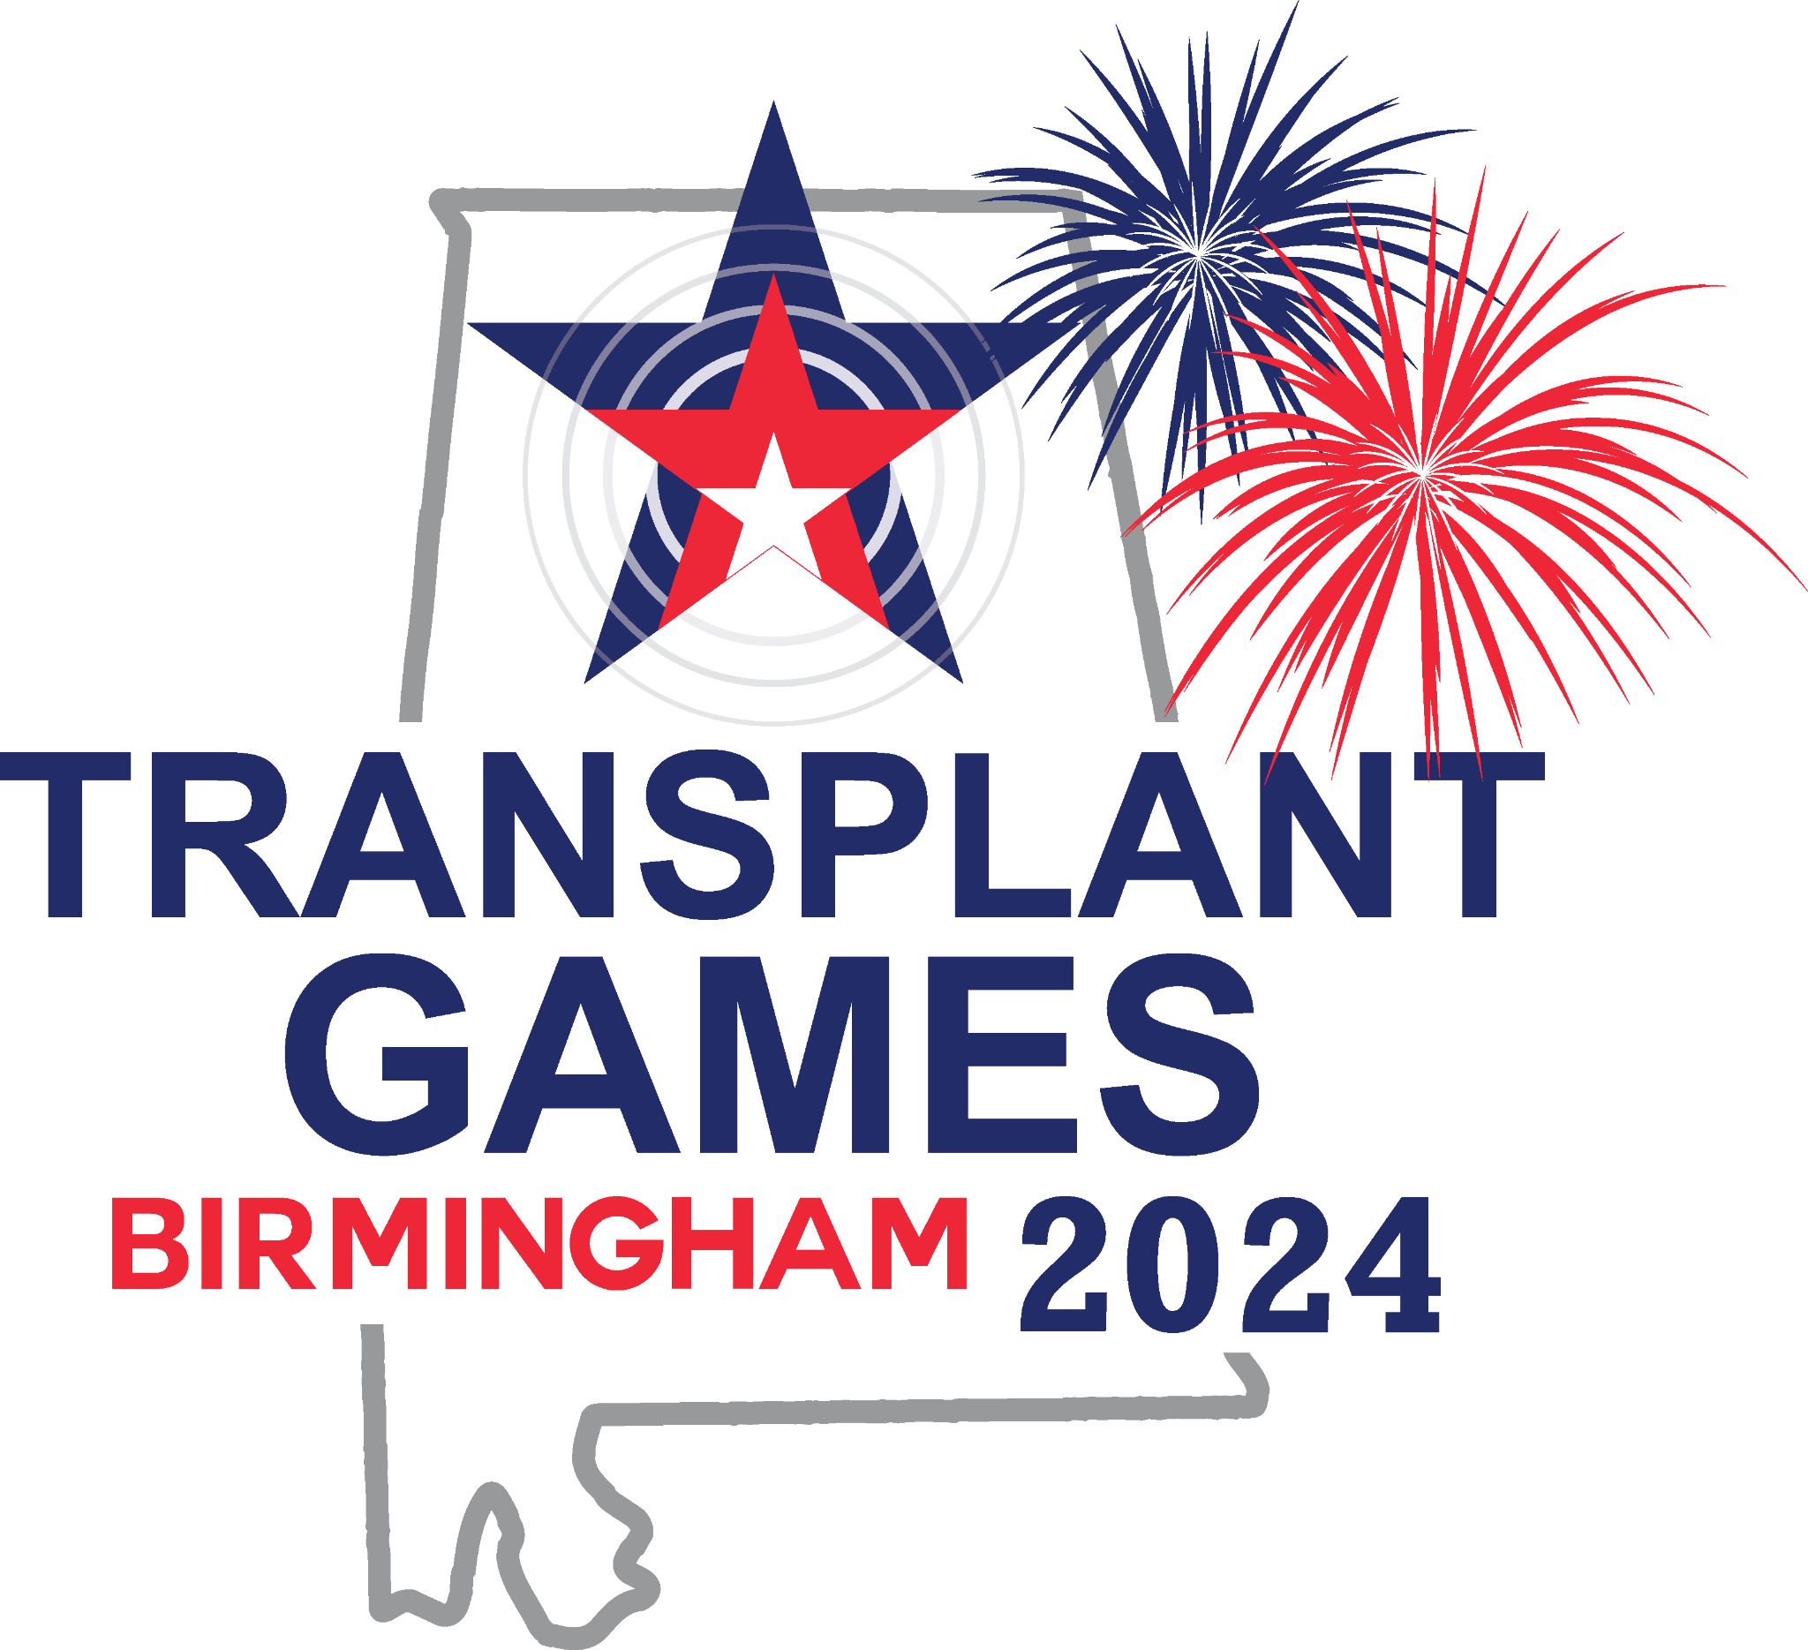

Quilt Square Kit

If you would like a donor quilt square kit, please email Taylor Heaton @ t.heaton@transplantLF.org.

Please type “Quilt Square Kit” in the subject line and include your name, mailing address and phone number in the body of the email.
Transplant Games of America will mail you a plastic bag that contains a muslin quilt square and basic instructions on creating a quilt square. Once you receive the quilt square in the mail you can click on the Quilt Square Instructions and Quilt Square Submission Form to indicate you would like to bring your quilt square and participate in the Quilt Pinning Ceremony at the 2024 Transplant Games in Birmingham, AL.

