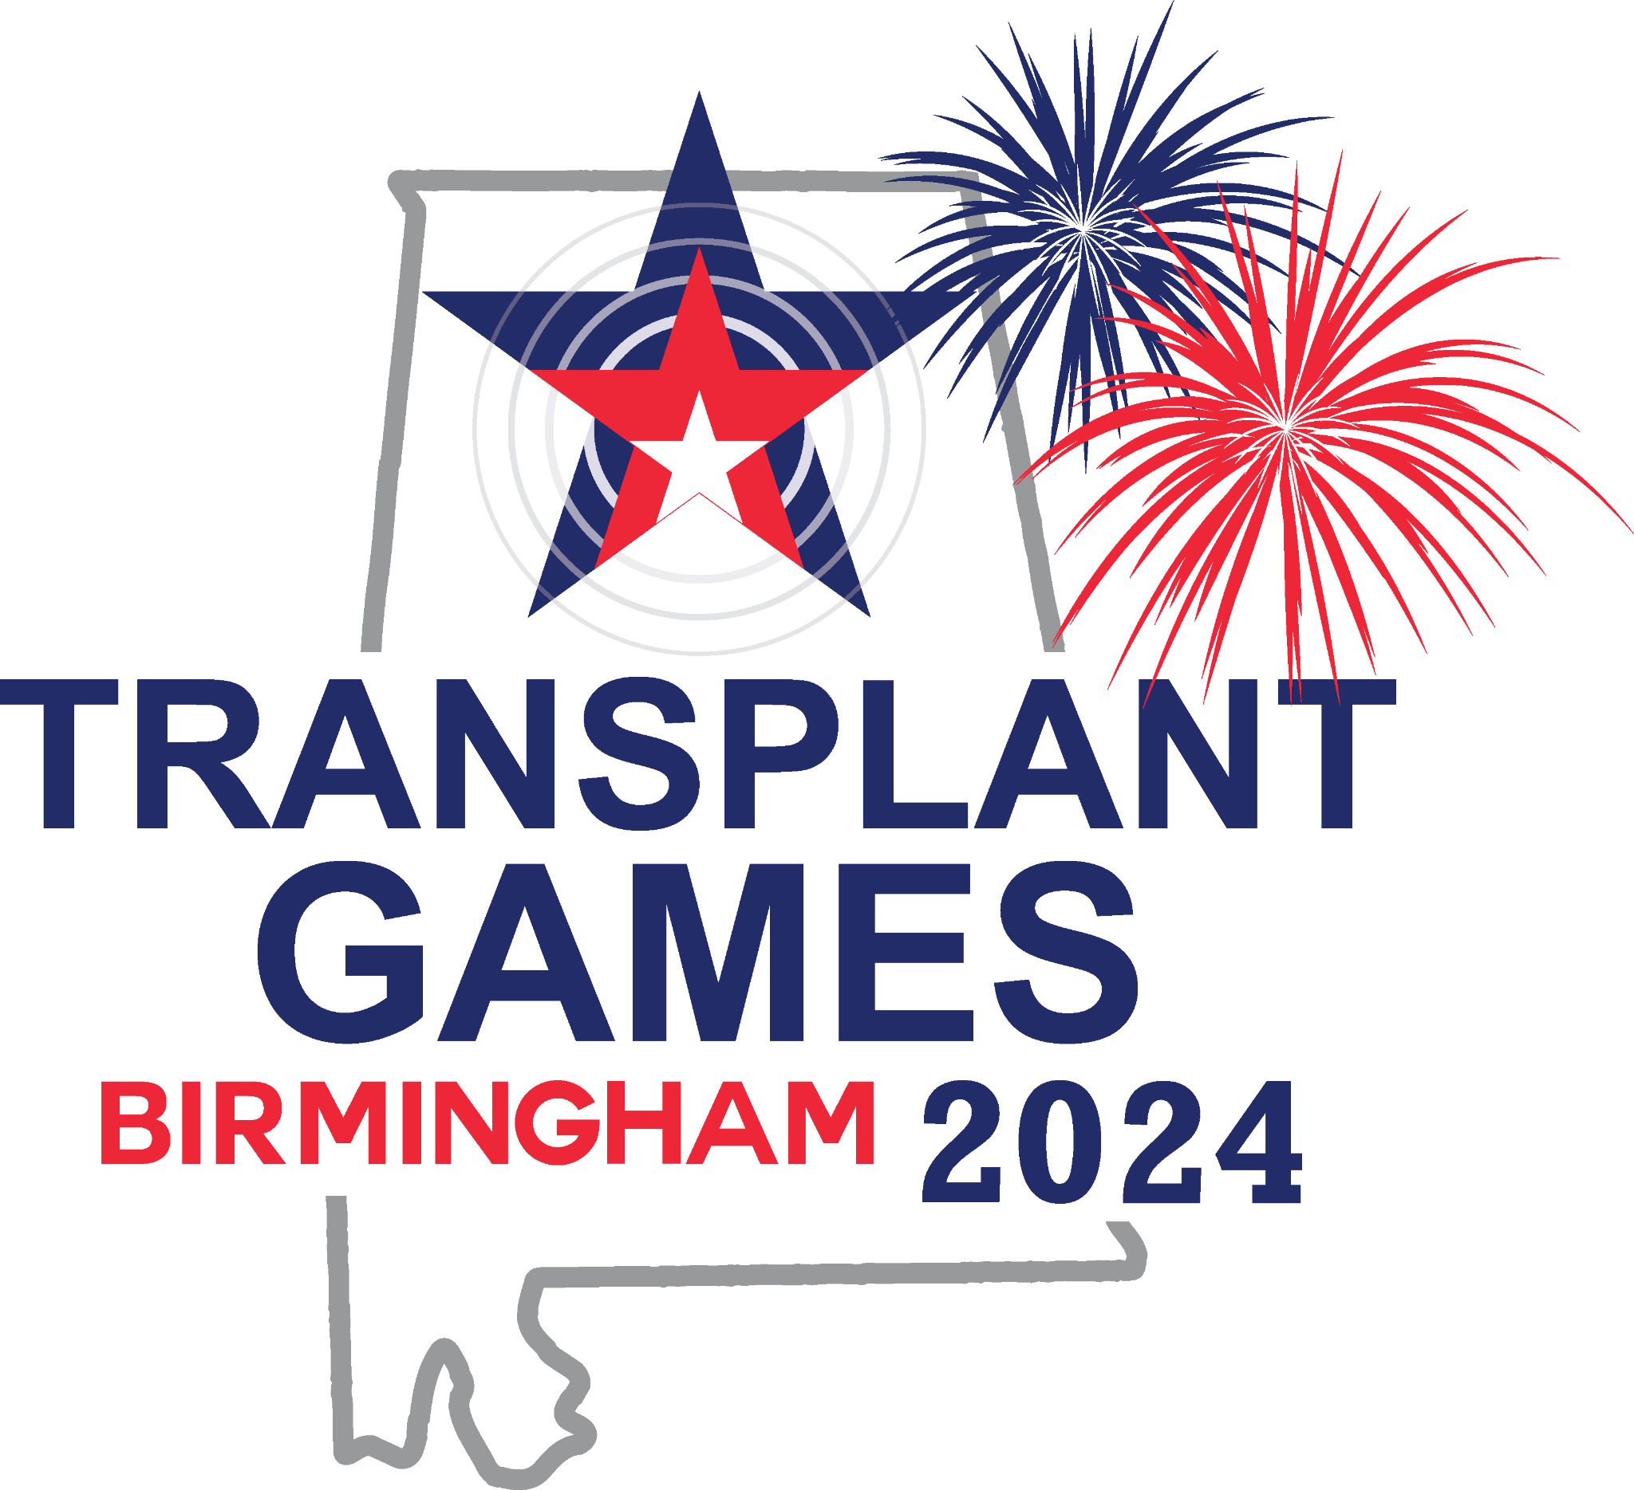

Quilt Squares

Transplant Life Foundation encourages attendees of the Transplant Games to create a donor quilt square in honor of a loved one who gave the gift of life and participate in the Quilt Pinning Ceremony at the Games. Each quilt square tells the story of an individual donor and together on the quilt they represent the spirit of giving through the act of organ, eye, and tissue donation.
Please bring your pre-made quilt square with you to the Quilt Pinning Ceremony at the Games. You will have an opportunity to say a few words about your loved one and pin your square on a Transplant Games of America quilt. You will leave your quilt square pinned to the quilt and Transplant Life Foundation will then bring these pinned quilts back to Grand Rapids, MI to be finished by a professional quilter. These completed quilts will then travel with the Transplant Life Foundation to other organ donation events and to future Transplant Games of America to pay special tribute to the donors and raise awareness for the critical need for organ donation.

Basic Instructions for Creating Quilt Square
Your quilt square should be 10” square, leaving ¼” on all four sides.
Decide on your design.
Fabric can be of any color or type. (white muslin comes with the TGA Quilt Square Kit)
Please do not use glue, stickers, or crayons.
Basic materials you may need: scissors, ruler, needle and thread or sewing machine, paint (not watercolor), fabric pens/markers, photos, buttons, pins, pieces of clothing, and other memorabilia that can be securely fastened.
Do not finish the square with quilting or backing.

Frequently Asked Questions
How to come up with a quilt square design?
Think of what was important to your loved one and what things remind you of them. This may be a piece of his or her favorite part of a blanket, a high school jacket or patch, a pocket from old jeans etc.
You may also include poems, quotes, significant ideas, names, any other symbols of your loved one’s life.
What are some options for adding a photo to my quilt square?
Iron on transfer paper:
Put transfer paper in your printer and print photo. Then place paper, photo side down, onto the fabric and iron. When you remove the transfer paper, your photo will be seen on the fabric.
Print on photo paper:
You can have a digital image printed by a local drugstore and then sew that photo directly onto your quilt square.
Lamination:
How do I make sure everything on my quilt square is secure enough?
When the quilt with the quilt squares is completed by the quilter, it is important that all embellishments on the quilt square are as secure as possible. Each embellishment should be stitched on. If you can shake your quilt square without the embellishments moving or falling off, that is a good sign they are secure.
Can I submit a quilt square even if I cannot attend the Quilt Pinning Ceremony at the Games?
Yes, you can drop off your quilt square and submission form at a designated table near registration during the first two days of the Games.
Can more than one quilt square be made for a single donor?
Absolutely, we welcome as many squares as people are willing to create. However, a separate Quilt Square Submission Form is needed for each square.

